**EXAMPLES OF PRODUCTS CONTAINING INSECTICIDES LABELED FOR USE IN LANDSCAPES AND GARDENS:**

**Contact insecticides (bifenthrin, carbaryl) ‐ apply when adult insects are present:**

* AVALON INSECTICIDE
* BIFEN 7.9F SELECT
* FERTI‐LOME BROAD SPECTRUM INSECTICIDE
* FLEE READY‐TO‐USE YARD SPRAY
* HOME MD MAXIMUM DEFENSE YARD CONCENTRATE
* LESCO CROSSCHECK PLUS MULTI INSECTICIDE
* MAXXTHOR SG
* ORTHO MAX PRO
* SEVIN
* TALSTAR SELECT INSECTICIDE
* UP‐STAR GOLD INSECTICIDE

**Systemic insecticides (imidacloprid, dinotefuran) – most effective when applied in spring and summer, before adults build up:**

* BAYER ADVANCED 12 MONTH TREE & SHRUB INSECT CONTROL
* BONIDE ANNUAL TREE AND SHRUB INSECT CONTROL WITH SYSTEMAXX
* COMPARE‐N‐SAVE SYSTEMIC TREE & SHRUB INSECT DRENCH
* GREEN LIGHT TREE & SHRUB INSECT CONTROL WITH SAFARI
* MONTEREY ONCE A YEAR INSECT CONTROL II
* ORTHO BUG B GON YEAR‐LONG TREE & SHRUB INSECT CONTROL CONCENTRATE
* SPECTRACIDE TREE & SHRUB INSECT CONTROL
* TRANSTECT 70 WSP INSECTICIDE
* VENOM INSECTICIDE
* ZYLAM LIQUID SYSTEMIC INSECTICIDE

**Photo of Nymph almost an Adult**

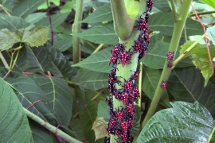

**PHOTOS OF ADULT SPOTTED LANTERNFLY**

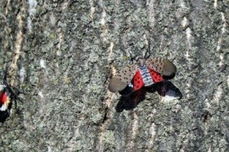

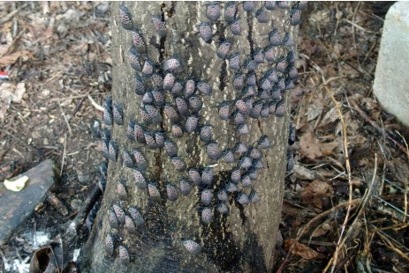

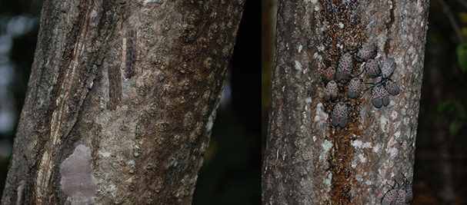

**EXAMPLES OF PRODUCTS CONTAINING INSECTICIDES FOR USE ON VEGETABLES, FRUIT, BERRIES AND GRAPES:**

*WHEN USING INSECTICIDES ON EDIBLE CROPS: It is especially important to follow directions for chemical application and timing from harvest as stated on the label.*

* AGWAY COMPLETE FRUIT TREE SPRAY
* BONIDE COMPLETE FRUIT TREE SPRAY LIQUID
* BONIDE EIGHT INSECT CONTROL FLOWER &VEGETABLE ABOVE AND BELOW SOIL INSECT GRANULES
* HI‐YIELD VEGETABLE & ORNAMENTAL INSECT CONTROL GRANULES
* SEVIN
* VEGETABLE GARDEN SOIL INSECTICIDE

The products listed above are registered for use in specific settings. Read the pesticide label and follow the directions, including application rates, methods, and appropriate protective clothing and equipment.

THE LIST IS PROVIDED BASED ON CURRENT PRODUCT REGISTRATIONS. THIS IS NOT AN ENDORSEMENT OF ANY PRODUCT OR PESTICIDE PRODUCER. THIS IS NOT A COMPLETE LIST OF POSSIBLE LABELED PRODUCTS OR BRANDS.

***THESE INSECTICIDES HAVE NOT ALL BEEN TESTED AGAINST SPOTTED LANTERNFLY SPECIFICALLY, AND ADDITIONAL EXPERIMENTS ARE NEEDED TO DETERMINE THEIR EFFICACY.***

***Photo of Young Nymph***

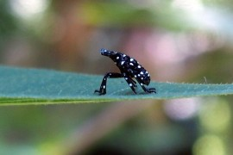

**If you want to kill Spotted Lanternflies without controlling *Ailanthus*:**

When there are only a few insects, you can kill spotted lanternflies by swatting or crushing them. For large populations, two kinds of insecticides are widely available that will kill Spotted Lanternfly adults.

**Contact insecticides** kill spotted lanternflies when the chemical contacts the insect directly. **Systemic insecticides** are absorbed by the tree and kill insects feeding on it. **ALL** insecticides must be used as directed on the label. Take the time to read the label carefully and follow the directions. This increases your safety, the safety of the environment, and the effectiveness of the insecticide. Pennsylvania law requires that pesticide labels list the site where a pesticide (such as an insecticide) may be used. In Pennsylvania, insecticide labels do not have to specifically list the targeted insect. There are insecticides labeled for use on ornamental trees and around buildings. These products are legal to use on the sites listed in order to control Spotted Lanternflies in Pennsylvania.

Penn State Extension is currently testing to determine which insecticides are most effective in controlling adult spotted lanternflies. Preliminary results show insecticides with the active ingredients ***dinotefuran*, *imidacloprid, carbaryl, and bifenthrin*** are effective at controlling the spotted lanternfly.

Neem oil and insecticidal soap provided some control, but results varied, and insects sometimes took several days to die. Examples listed below are some of the available insecticide products containing the most effective ingredients studied (***dinotefuran*, *imidacloprid, carbaryl, and bifenthrin)***.



September 2017

**How to Eliminate or Control Spotted Lanternfly Adults:**

**Any question, to report or more for information please direct inquiries to:**

**1-866-253-7189 or** [**Badbug@pa.gov**](mailto:Badbug@pa.gov)

**John Baker  
Spotted Lanternfly Project Coordinator  
(717) 461-6637**[**johnbak@pa.gov**](mailto:johnbak@pa.gov)

**Information provided by:**



**Flyer made by Borough of Souderton for distribution to residents.**

**If you find Spotted Lanternflies in a municipality where they are known to exist, you should try to kill them.**

The most effective way to eliminate these insects is to disrupt their favorite food and hang‐out. In late summer and fall, Spotted Lanternflies prefer feeding on *Ailanthus altissima,* commonly known as the "Tree of Heaven." They can be found feeding on other plants and trees, but *Ailanthus altissima* is their favorite host. Here’s an excellent resource to help you identify the tree: https://pubs.ext.vt.edu/content/dam/pubs_ext_vt_edu/420/420‐322/420‐322_pdf.pdf

**If you have *Ailanthus* on your property:** please consider reducing the number of *Ailanthus* trees, then treat remaining “trap trees” with insecticides. This is a longer‐lasting solution than simply spraying insects you see. More detail about this process can be found at the following websites:

<http://www.agriculture.pa.gov/Protect/PlantIndustry/spotted_lanternfly/Documents/What%20to%20do%20if%20you%20find%20spotted%20lanternfly%20on%20your%20property%20fact%20sheet%20February%202017.pdf>

<http://www.agriculture.pa.gov/Protect/PlantIndustry/spotted_lanternfly/Documents/Spotted%20Lanternfly%20%20Property%20Management.pdf>