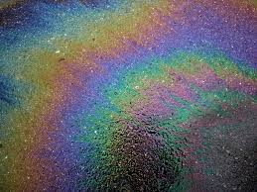
Rainbows are for discovering pots of gold –
Not pools of toxins!!

Next time it rains, look down at your driveway or the nearest parking lot. See any colorful “oil rainbows” slicked across the pavement? It’s a sign that someone’s car is leaking fluids. The rainbows might look pretty, but these fluid leaks are composed of highly toxic materials such as antifreeze, motor oil, brake fluid and/or transmission fluid. When the toxins enter the storm drain system or leach into the soil, our surface and groundwater supplies are contaminated and that means your drinking water supplies are put at risk. You rely on your car for safe, convenient transportation. Why not treat it right and protect water quality at the same time?
- Repair auto fluid leaks right away. Use a drip pan to catch leaks if repairs are delayed.
- Collect and dispose of fluids from routine maintenance properly.
For help with the disposal of home toxic materials, search “Montco Household Hazardous Waste Collection Program 2019” to see the collection dates and sites and what can and cannot be disposed of at these events.

