Erosion & Sedimentation Controls
Did you ever wonder what these things are? You see them everywhere, but what are they? These are just some of the control measures that must be used on construction sites to prevent stormwater pollution and sediment runoff. Both types of silt fencing help to filter sediment out of the stormwater before it leaves the construction site. Rock construction entrances help keep soils from being tracked onto public roads by construction vehicles. All of these measures help to keep our local waterways clean.
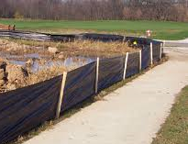 | 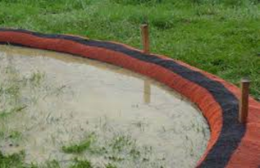 | 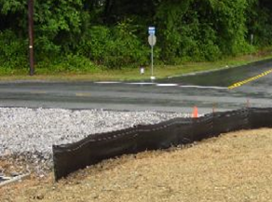
SILT FENCE | SILT SOCKS | ROCK CONSTRUCTION ENTRANCE

