Keep Your Waterways Clean – No Dumping in Stormwater Inlets
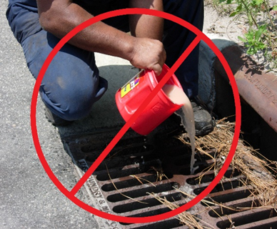
Your community is designated by the Pennsylvania Department of Environmental Protection as an MS4 – Municipal Separate Storm Sewer System and must maintain an NPDES Permit (National Pollutant Discharge Elimination System). The primary goal of this program is to improve stormwater runoff quality, which impacts streams and rivers in the community.
One thing that the public can do to help prevent Stormwater Pollution is to never dump pollutants into a storm sewer inlet, drainage ditch or basin. This includes paint, chemicals, detergents or petroleum products, as well as grass clippings and leaves. These facilities drain directly to the local streams and dumping anything other than stormwater causes pollution that is harmful to the aquatic life and pollutes the waters which we use for recreation.

